**My, Art 385, Blink Without Delay, 03/31/2020**

**Assignment**

Use Blink Without Delay or MSTimer to create ‘simultaneous’ multiple outputs (and/or read multiple sensors

**Diagrams**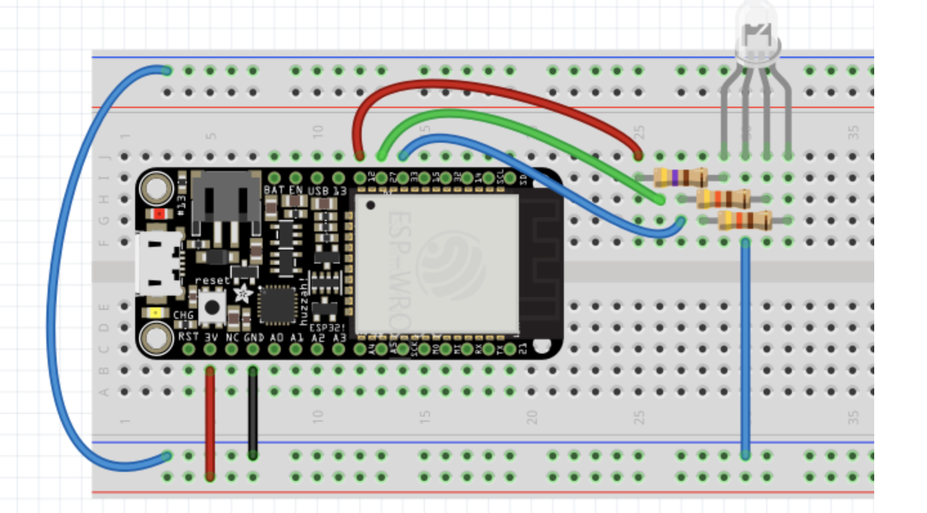

**Reflections**

This was a little challenging because I was not as familiar with the use of MSTimer. I just looked at the tutorials and kept my diagram/set up the same as before. I am not sure if I actually did what the assignment asked for but I asked some CS students/classmates who think this was correct. :-)))